**Deep Learning   
Lab Assignment – 2**

* Saidu Babu Dosapati
* ID: 12533623

**Introduction:**

Text Classification using CNN (Convoluted Neural Networks)

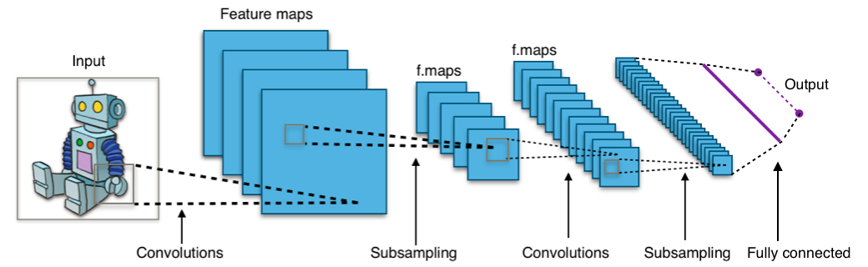

**Objectives:**

Implementation of CNN using Tensor Flow, Numpy and pandas machine learning libraries.

**Approach:**

Though we have several different approaches like Artificial Neural Networks, Recurrent Neural networks. Our approach for classifying the given text is by proceeding through Convoluted Neural Networks.

**Method:**

Convoluted Neural Networks

**Workflow:**

1. Importing the required libraries
2. Importing Numpy, Pandas, OS, time, datetime, datahelpers, textCNN, Tensor Flow
3. Loading the parameters like Data, Model and Training
4. Pre processing the data
5. Loading the required data
6. Building the vocabulary
7. Shuffling the data randomly
8. Train data and test data split
9. Performing the Cross validation
10. Training the data
11. Defining the training procedure
12. Keeping the values of gradient descent and sparsity
13. Outputting the directories for summary and models
14. Loss and accuracy summaries
15. Train and Development summaries
16. Checkpoints
17. Generating batches and training the loop for each batch
18. Evaluating the parameters
19. Providing the epochs number of operations
20. Getting the Tensor Boards

**Datasets:**

Data1.txt

Data2.txt

**Parameters:**

* + Data Loading Parameters:
    - Tf.flags.DEFINE_float,
    - Tf.flags.DEFINE_string
  + Model Hyper parameters:
  + Training Parameters:

**Evaluation & Discussion:**

1. Defining the data parameters
2. Defining the evaluation parameters
3. Miscellaneous parameters
4. Mapping the data on to our vocabulary
5. Evaluation
6. Loading metadata, getting placeholders, evaluating the tensors by generating the batches and collecting the predictions
7. Printing the accuracy
8. Outputting the values into a .csv file

**Conclusion:**

